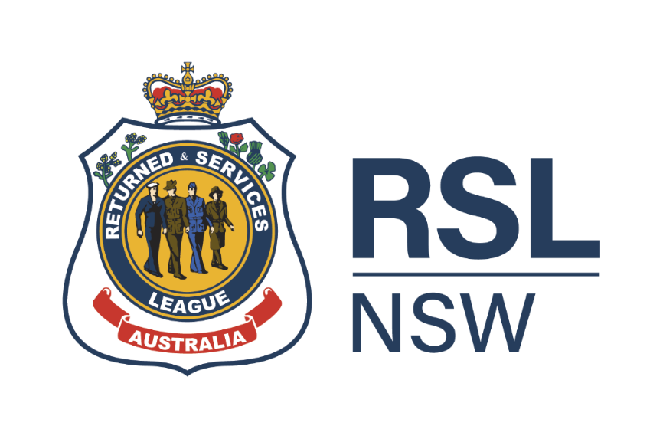

Charter

Fundraising Committee

Version: | 1
Document status: | Approved
Approved by: | RSL NSW Board
Effective date: | 29 March 2023
Review date: | March 2025

Table of Contents
1. Purpose 3
2. Powers of the Committee 3
3. Composition and Meetings 3
3.1 Membership and attendance at meetings 3
3.2 Quorum 4
3.3 Committee Papers 4
3.4 Committee minutes 4
3.5 Meetings 4
4. Conflict of Interest 5
5. Committee Review 5
6. Reporting and Accountability to the Board 5
7. Definitions 6
8. Document Governance 6

Purpose
The Fundraising Committee (Committee) of the Board of RSL NSW (Board) has been established in accordance with the RSL NSW Constitution (Constitution).

The Committee is responsible to the Board of RSL NSW for leadership and strategy in relation to:
- setting annual state-wide fundraising goals;
- developing fundraising initiatives to increase revenue to support RSL NSW charitable cause, build donor base and increase strategic long term corporate partnerships;
- assisting management to develop annual RSL NSW Fundraising business plan to achieve revenue objectives contained in the RSL NSW Strategic Plan;
- ensuring that the Board has a sound understanding of the principles and best practices that underpin successful fundraising;
- reviewing annual results and evaluating the return on investment (ROI) across all segments of the RSL NSW Fundraising business plan;
- working collaboratively with RSL NSW sub-Branches to support local fundraising initiatives;
- monitoring and providing advice to RSL NSW sub-Branches on relevant compliance -regulations and laws in regards to raising funds from the public; and
- promoting a culture of philanthropy in RSL NSW service members.

Powers of the Committee
The Board delegates to the Committee the powers and authority set out in this Fundraising Committee Charter (Charter). The Board may make other delegations to the Committee from time to time. This delegation does not relieve the Board of its responsibilities for these matters.

The Committee must exercise the powers delegated to it in accordance with any directions, strategies, objectives, or policies of the Board. Recommendations of the Committee shall not be binding on RSL NSW unless the recommendations are approved by the Board.

The Committee, in performing its functions, may:

- request any employee or service member of RSL NSW to attend a meeting of the Committee;
- to the extent permitted by law, access any document, report, material, or information in relation to raising funds in the possession of an employee or external adviser of RSL NSW;
- obtain reasonable independent professional advice via the Chief Executive Officer (CEO) to assist it in the proper exercise of its powers and responsibilities; and
- meet any reasonable travel, accommodation or out of pocket expenses incurred by Committee members in attending Committee meetings in accordance with any relevant travel policy.
Further, the CEO, Chief Financial Officer (CFO) and Communications Manager, or persons in similar roles, will have direct access to the Committee as needed.

Composition and Meetings

Membership and attendance at meetings
- The Committee comprises up to five members including:
- the RSL NSW President, who is an ex-officio member,
- at least two additional RSL NSW Board members, one of who will be a suitably qualified RSL NSW service member; and
- up to a maximum of two suitably qualified independent members appointed by the Committee;
- The Chair of the Committee is elected by the members of the Committee annually at the Committee’s first meeting held after the RSL NSW AGM. Any member of the Committee may be elected as the Chair.
- The RSL NSW Board Secretariat will provide the Secretary for each Committee meeting.
- The Board appoints and may remove any member from the Committee at any time with or without cause, including the Chair of the Committee. If the Chair is removed by the Board, the Committee will elect another member at the next following Committee meeting.
- The Chair, or the Secretary at the request of the Chair, may invite any of the following to attend a meeting of the Committee:

  - any employee or service member of RSL NSW; and
  - external Subject Matter Expert.

Quorum
At least fifty percent plus one of the members of the Committee, present in person or by using any technology, will constitute a quorum. The quorum must be always present during the meeting.

Committee Papers
Unless directed by the Chair, the Committee Secretary will distribute in advance of a meeting of the Committee an agenda and any related papers to:
- each member of the Committee;
- the CEO, CFO, the Communications Manager, and other members of the management team; and
- if requested, to any Board Director.

Committee minutes
- The Committee Secretary will prepare minutes of meetings and have them approved by the Committee Chair.
- Minutes of meetings shall be submitted to the next meeting of the Committee.
- Minutes signed by the Committee Chair shall be conclusive evidence of the matters recorded in such minutes.

Meetings
- The Committee will meet at least four times a year, or more frequently as circumstances dictate.
- Meetings may be face-to-face, or via telephone or video conference as considered appropriate by the Committee Chair.
- Meetings may be held in person, by telephone or by video conference, or by any combination of these media.
- The Secretary takes the minutes of the proceedings of all Committee meetings.
- A member of the Committee may request that a meeting of the Committee be convened.

Conflict of Interest
If any Committee member has a material personal interest in or an interest by way of a personal or other relationship to any matter being considered by the Committee, then that Committee member must give the Committee and the Company Secretary notice of that interest as soon as that member becomes aware of the interest. Such a notice must give details of the nature and extent of the interest and the relation of the interest to the affairs of RSL NSW.

Committee Review
- The Committee will review its performance periodically, including to consider whether it is performing effectively and has met the terms of this Charter, and will report the outcome of the review to the Board.
- The Committee will review this Charter at least every two years to ensure it remains current to the needs and structure of RSL NSW and recommend amendments to the Board for approval. This Charter may only be amended by a resolution of the Board.

Reporting and Accountability to the Board
The Committee is accountable to the Board for the exercise of the Committee’s responsibilities and delegated authority under this Charter. The Committee will:
- submit copies of its minutes to the Board for noting;
- report to the Board on the exercise by the Committee of its authority;
- through the Committee Chair, provide updates and make recommendations to the Board on matters that are within the scope of this Charter; and
- through the Committee Chair, promptly bring to the attention of the Board any matters before the Committee that may materially impact the financial condition, risk profile or affairs of RSL NSW, or any material non-compliance with applicable laws.

However:
- The delegation of authority under this Charter does not preclude the Board from exercising power or authority in relation to a matter that is within the Committee’s delegated authority, if the Board so decides.
- In addition, the Committee may at any time, through the Committee Chair, refer any matter that is before the Committee to the Board for consideration (even if that matter falls within the Committee’s authority under this Charter to approve).

Definitions
TERM | DEFINITION
Board | The Board of RSL NSW
Charter | This document, outlining the purpose, scope, responsibilities, and composition of the Committee
Committee | Fundraising Committee
Committee Chair | A person elected by the members of the Committee annually
Committee Secretary | The RSL NSW Board Secretariat
Constitution | The RSL NSW Constitution
Responsible Executive | RSL NSW’s Chief Financial Officer

Document Governance
CODE DOCUMENT NAME
Associated written directions: | - RSL NSW Constitution 2019, as amended 2022  - RSL NSW Strategic Plan 2020 – 2026, as updated 2022
Related legislation: | - ACNC Governance Standards  - RSL NSW Act 2018 (NSW)  - RSL NSW Constitution 2019, as amended 2022  - NSW Charitable Fundraising Act, 1991 (NSW)  - NSW Charitable Fundraising Regulation 2021 (NSW)  - Corporations Act 2001 (Cth)  - Charities Act 2013 (Cth)  - ACNC Act 2012 (Cth)  - ACNC Regulation 2013 (Cth)
Endorsed by: | Interim Fundraising Committee | 14 March 2023
Approved by: | RSL NSW Board | 29 March 2023
Written directions owner: | Jeff O’Brien, Company Secretary
Date effective: | 29 March 2023
Publication: | Uploaded to Diligent Resource Centre
Version: | 1.0
Content enquiries: | Jeff O’Brien, Company Secretary
Review date: | March 2025

